
Send and receive server test log
Distributed Systems

November 3, 2025
Blackpool & fydle college

Test Logs
I tested my send-and-receive server configuration for the first time. Nevertheless, a traceback issue pointing to the source code file appeared when I attempted to execute the client server:
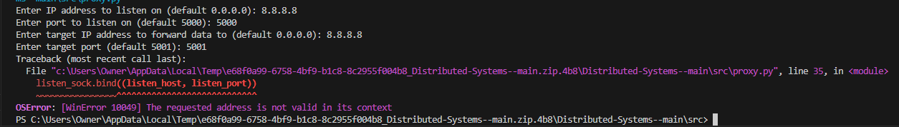
When I restarted the client server, it showed the messages "listening on 0.0.0.0:5000" and "sending on 0.0.0.0:5001," indicating that the server was successfully operating and prepared to send and receive data on those ports, rather than a traceback error pointing to the most recent portion of the code:
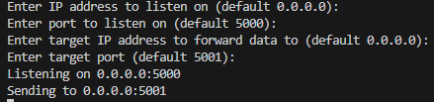
I then started executing the send.py script, which asked me to provide my name, age, and marital status, among other personal details. I needed to confirm whether the data will be successfully sent to the JSON receive server after supplying these details:
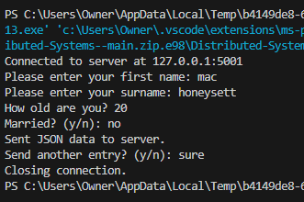
This output verifies that the server successfully received the transmitted data by displaying the outcome of the send and receive server interaction. The data exchange process came to an end when it acknowledged the receipt and signalled that the connection had been closed:
This is the finished code with the questions and changes that were asked. I ran across a problem during implementation when Visual Studio Code couldn't connect to the server using the original IP address. I modified the default IP to "127.0.0.1," which refers to the local host, to fix issue. This guarantees proper communication between the client and server on the same system. Furthermore, clientServer.py is a script that serves as both the client and the server. Because the same module was attempting to handle both roles concurrently, this setup resulted in a naming and execution conflict in Python. To prevent such disagreements or role conflicts, the client and server are typically implemented in different scripts in network systems. These problems can be avoided by separating these functions or defining the role (client or server) with command-line options:
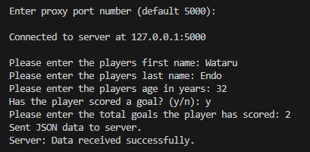
The server's activity and proper operation are confirmed by the proxy output that follows. Since the server can send and receive data, it verifies that bidirectional communication was successful. This shows that the client-server connection has been established correctly and that error-free data transmission is taking place:
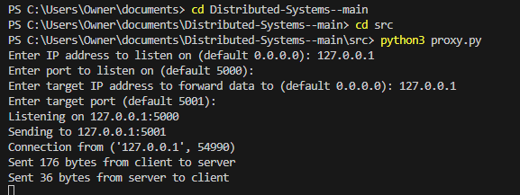

This part shows that a reliable connection has been established between the servers as the ClientServer has successfully received the transmitted data. This confirms that the client-server communication route is operating as planned, enabling appropriate interaction and data exchange:
